**Git and GitHub Assignment**

**GIT REMOTING**

**Section 3 : (Pushing Assignments in Remote Repository)**

39. Create a github account if you do not have already.

**I am already have a github account**

40. Login on into github account.

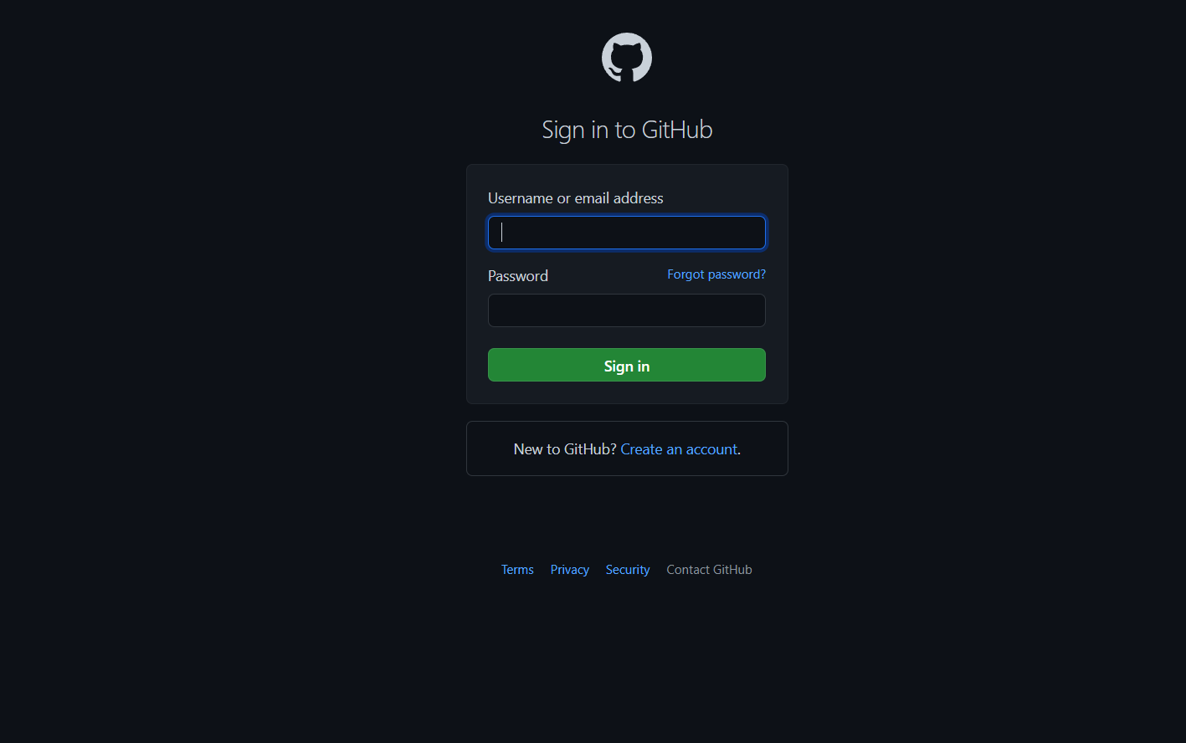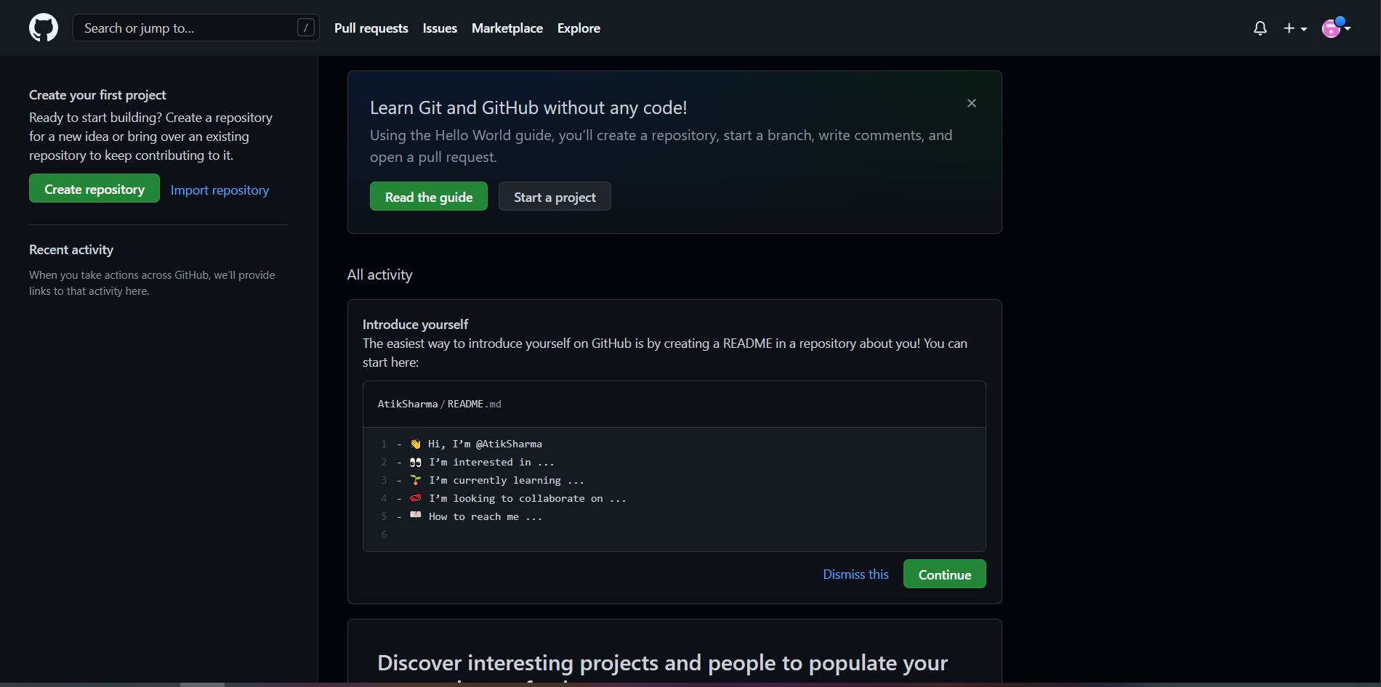

41. Create new public repository'freshersbatch-oct16'.

**Created a new repository named “SampleRepo”**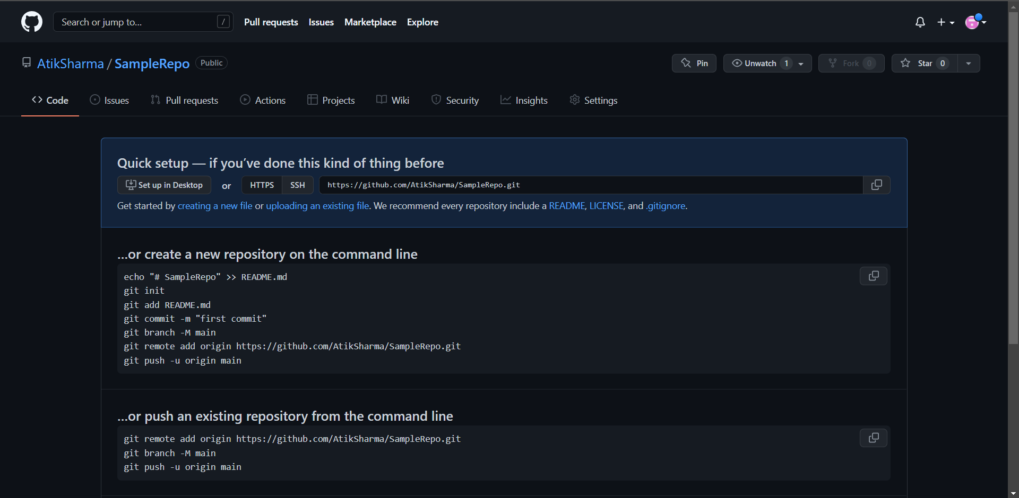

42. Commit & push any sample file to this repository under 'Assignments' directory.

**Creating a assignment folder and sample demo.txt file**